<http://www.dailymotion.com/video/x27zdlu_en-m2m-in-smart-agriculture-with-dacom_tech>

<http://www.electroschematics.com/10969/smart-water-tank-pump-switcher/>

<http://electronicsforu.com/electronicsforu/circuitarchives/view_article.asp?sno=50&article_type=1&id=780&tt=unhot>

<http://media.digikey.com/Resources/Cynergy3/Cynergy3-Pump-Control.pdf>

<http://www.eleccircuit.com/automatic-water-tank-using-pump-controller-by-2sd882/>

<http://www.instructables.com/id/AUTOMATIC-WATER-CONTROL-WITH-AUTO-SHUT-DOWN-WATER--1/>

Automatic valve regulation

For an automatic valve control we are using a stepper motor as an actuator control of the valve which is connected to the outlet valve of the tank. With the help of moisture sensor signal and a controller, a control pulses is given to the driver circuit that excites the stepper motor. So this way the outlet valve is slowly opened or closed depending upon the amount of moisture present in the soil of the field. When the soil moisture content reaches the required value, the valve is fully closed and power to driver circuit is killed and controller is put into sleep mode for low power consumption. When the moisture in soil is dried and reach a minimum cut-off value, the controller comes out of sleep mode and flow of water is regulated. This way the whole system works automatically.



**Automatic Water Tank Pump Switcher:**

Traditional water level controller has many problems and it can burn the pump as well if no or less water (below limits) is reached. Therefore automatic pump controller switch is being established. It has two possible ways in which it can be implemented, by

* Micro-controller Atmega328P-PU.
* 555 timer IC.

**Through Micro-Controller:**

**Microcontroller Unit:**

A number of LEDs will be attached to the controller to display status, an electromagnetic relay for switching pumping motor and some other components attached to controller.

Basically there will be two ports connected to controller for water level detection.

* Visual status indication for high level
* Visual status indication for low level

Water level will be detected by programming the controller this will enable to detect the high and low of overhead tank.

**Water Level Sensors:**

**Reed-switch will be vertically mounted on different heights of overhead tank. The basement water tank also be consisting of single point level switch to check whether the tank is dry or not, this will save the pump from getting the motor burned. Hermetically sealed-in-glass reed switches located inside the stem are activated/deactivated by the upward/downward movement of the strong magnet in the tailpiece of the float.**

**Power Supply Unit:**

**The circuit will be functional between 9-12V of DC supply. This assures that 1A current can energize the whole system. Voltage regulator is still needed to make sure that clean dc supply will run through circuitry.**

**System Description:**

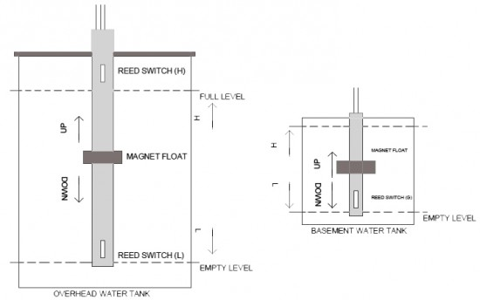 **Two sensors at different position will be attached in overhead tank to determine the high/low levels of water. If the water level is low i.e. L sensor, trigger the low level port of controller and the pump will get activated. The STANDBY LED will turn off and PUMP ON LED will light up. When high level of tank will be reached i.e. H sensor, will be activated which will trigger high level port of controller, which will make the pump off temporarily. The PUMP ON LED will get off and STANDBY LED will be on. It will again be reactivated as the water will reach the low level sensor.**

**An optional sensor will be attached in the basement tank to make sure whether the water is available in underground tank or not to inform the controller not to turn ON the pump, no matter if the overhead tank gets empty.**

**Through 555-timer IC:**

**This design is based on voltage difference i.e. it will detect the level of water for e.g. high/low by voltage differences. The circuit will be functional at 12V dc supply and three different sensors will be used to be placed at high and low levels.**

**Mechanism:**

**When the water level gets low or below its marked point, the voltage at PIN 2 becomes low. This will make the internal SR-flip-flop reset and output will gets HIGH. The high output will be generated at PIN 3 which will initiate the relay driver transistor and will energizes the relay attached to it. Water pump gets mains power supply through n/o contacts of the relay and is powered on. It starts filling water in the tank.**

**When the water level get high or above its marked point, the voltage at PIN 6 becomes high. This will make the internal SR-flip-flop reset and output will gets LOW. The low output will be generated at PIN 3 which will cut-off the relay driver transistor and will de-energizes the relay attached to it. Water pump disconnects from the mains power supply through n/c contacts of relay and goes off. This stops the water flow.**

